Exploring Linux SSL Certificates

**Task 1: Introduction to SSL Certificates (Research)**

Introduction : SSL (Secure Sockets Layer)

- SSL certificates are a fundamental component of online security.
- SSL certificates are digital certificates that establish a secure encrypted connection between a web server and a user’s browser. They serve two primary functions:

- Authentication : SSL certificates verify the identity of the website’s owner,ensuring users are communicating with the intended website and not an impostor.
- Encryption : SSL certificates encrypt data transmitted between the user's browser and the web server, making it indecipherable to anyone intercepting the data.

Importance of SSL certificates :

- Data Protection : They protect sensitive information,such as personal details,login credentials and payment information from dropping and theft by encrypting it during transmission.
- User Trust : seeing the padlock icon or “HTTPS” in the browser’s address bar instills trust in users,assuring them that their data is secure.
- SEO Ranking : Search engines prioritize websites with SSL certificates,potentially improving a site’s search engine ranking.
- Regulatory Compliance : SSL encryption is often required to comply with data protection regulations and industry standards.

Types of SSL Certificates:

1. Domain Validation (DV) Certificates :
- DV certificates are the most basic type.
- They only verify the domain ownership and offer a low level of trust.
- Ideal for personal websites or small blogs.
2. Organization validation(OV) Certificates:
- OV certificates provide a higher level of validation.
- The Certificate Authority (CA) verifies the domain ownership and the organization’s details.
- Suitable for business websites and e-commerce platforms.
3. Extended Validation(EV) Certificates:
- EV certificates offer the highest level of validation and trust.
- The CA performs through verification of the organization’s identity.
- EV certificates display the organization’s name in the browser’s address bar,enhancing trust.
- Commonly used by financial institutions and e-commerce giants.
4. Wildcard Certificates :
- wildcard certificates secure a domain and all its suddomains.
- They are convenient for large organizations with numerous subdomains.
- Often used by businesses for multiple applications and services.
5. Multi-Domain(SAN) Certificates :
- SAN certificates secure multiple domain names with a single certificate.
- Suitable for businesses that manage several websites.
- A cost-effective solution for consolidating certificates.
6. Self-Signed Certificates :
- These certificates are generated by the website owner,providing encryption but labking third-party verification.
- Commanly used for internal testing and development environments.
7. Let’s Encrypt Certificates :
- Let’s Encrypt offers free SSL certificates.
- They are DV certificates and are suitable for small websites and blogs.
- Automated renewal simplifies maintenance.

**Task 2: Installing SSL Certificates (Practical)**

How to install and configure an SSL certificate for the apache web server on a linux virtual machine.

1. Install Apache
- Connect to your Linux virtual machine via SSH or access its terminal directly.
- Update the package list ensure you have the latest information about available packages:
ex : sudo apt update
- Install Apache using the Package manager:
sudo apt install apache2
- start apache and enable it to start on boot:
sudo systemctl start apache2
sudo systemctl enable apache2
- Verify that Apache is running by visiting yours server’s IP address in a web browser.
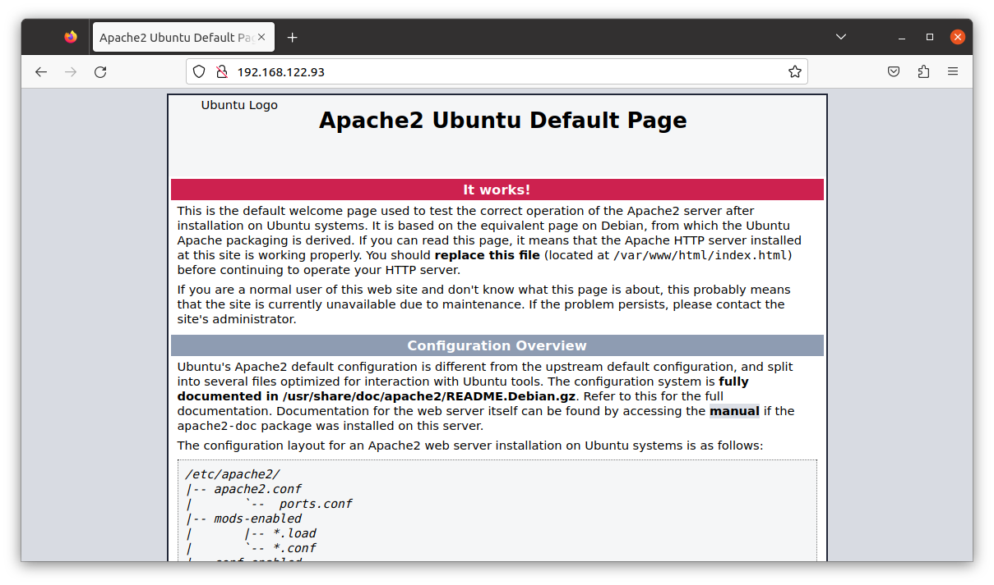
2. Obtain an SSL Certificate : In this example, we will use let’s encrypt to obtain a free SSL certificate. Let’s encrypt provides a tool called certbot to automate the certificate installation.

Sudo apt install certbot python3-certbot-apache

- Obtain and install the SSL certificate. Replace example.com with your domain:
sudo certbot –apache -d example.com
- Apache should be automatically configured by certbot,but you can review the configuration in the apache site files located in /etc/apache2/sites-available/.

Challenges and Issues:

- Ensure that your server’s firewall allows incoming traffic on port 80(HTTP) and 443 (HTTPS) for let’s encrypt to validate your domain.
- Make sure your domain is correctly configured to point to your server’s IP address.
- Change the file permisssions that apache has access to the necessary directories.
- Check your apache configurations files for any errors.

**Task 3: Creating Self-Signed SSL Certificates (Practical)**

- Self-Signed certificates are useful for testing and development environments but should not be used in production for public-facing websites.
- They are not trusted by web browsers and do not provide a same level of security as certificates signed by a trusted certificate Authority (CA).

- Install openSSL :

- check openSSL is installed on your system by using the command :
openssl version
- if not installed use the below comamnd to install the openSSL :
sudo apt install openssl

2. Generate a Self-Signed SSL Certificate :

- create a private key (RSA key in this example) :

openssl genpkey -algorithm RSA -out example.key

This generates a private key file named example.key

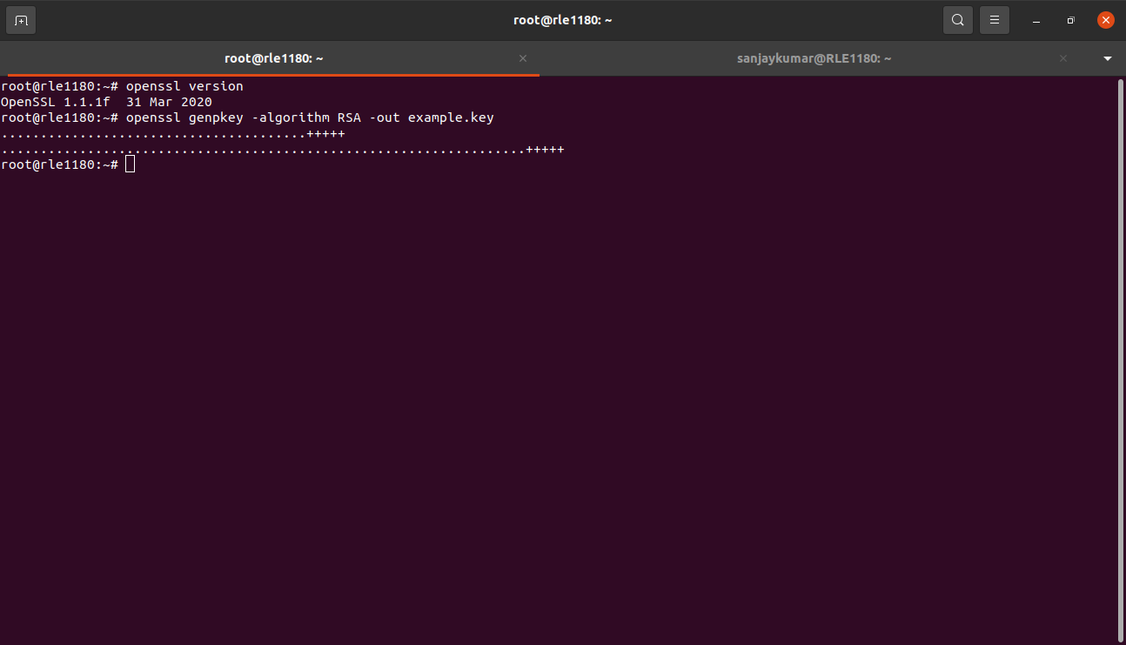

2. create a certificate signing request (CSR) using the private key :

openssl req -new -key example.key -out example.csr
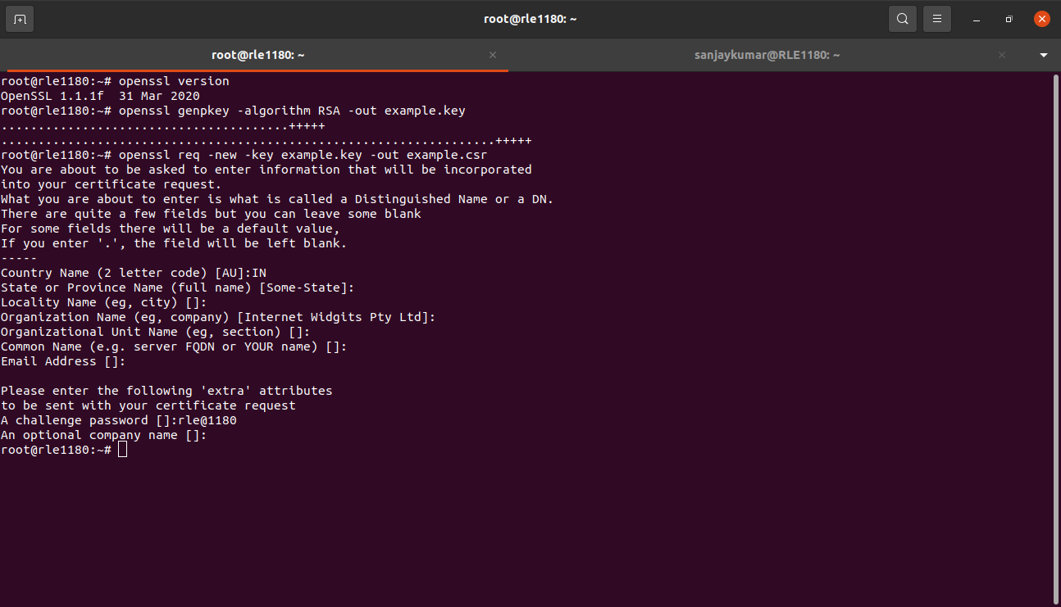
3. create a self-signed certificate using the CSR :

openssl x509 -req -in example.csr -signkey example.key -out example.crt

This command signs the CSR with the private key,producing the self-signed certificate in example.crt.

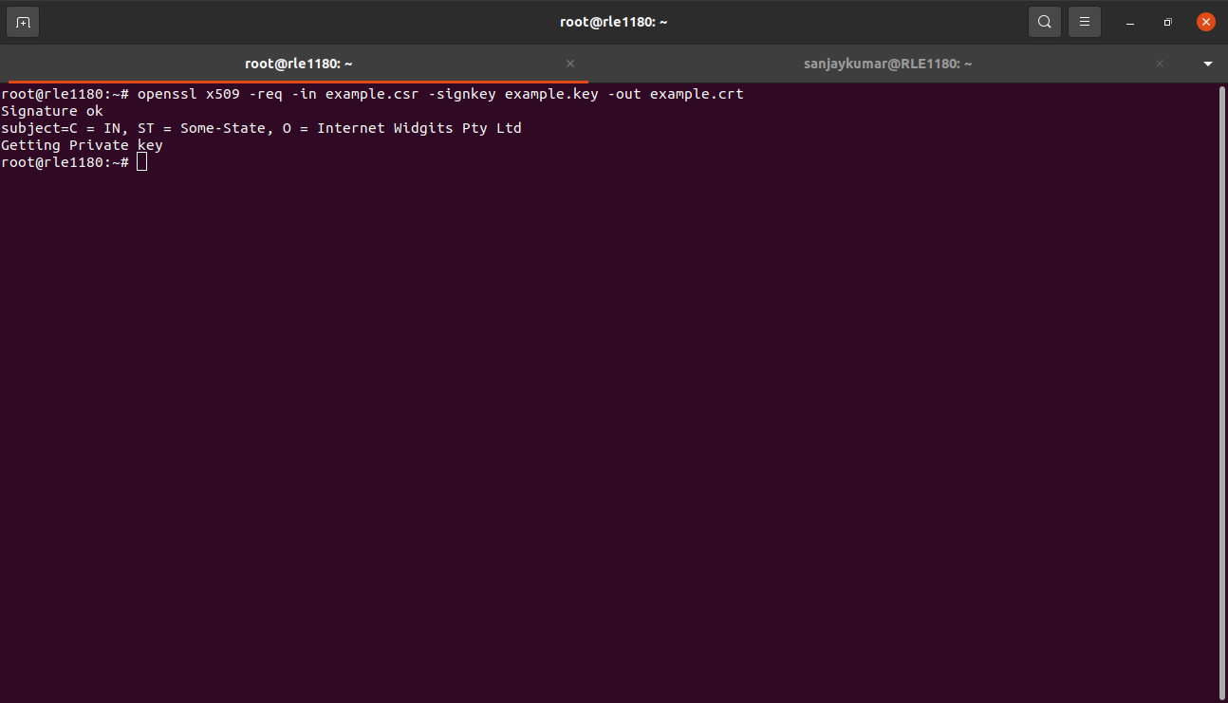

3. view the certificate information :

openssl x509 -in example.crt -text -noout

This will display information about the certificate, including its subject ,issuer and validity dates.

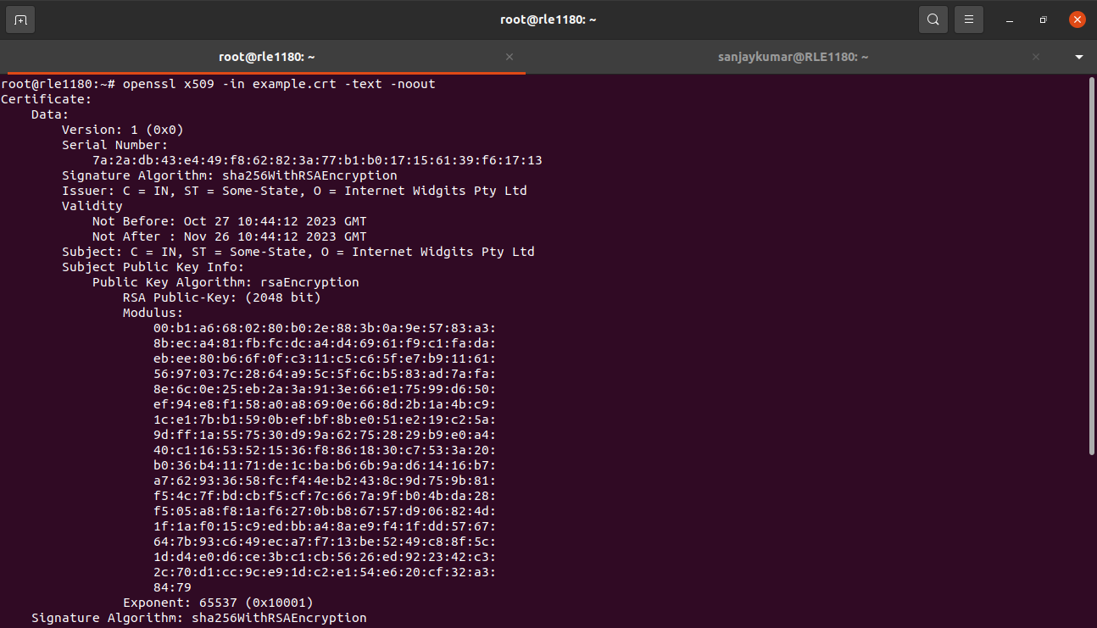

Self-Signed Certificates :

- self-signed certificates are SSL/TLS certificates that are signed by the entity they belong to, rather than a trusted third-party certificate authority (CA).
- They typically used for internal or testing purposes.

Use cases :

- Development and Testing : Self-signed certificates are useful for developers and testers when working on web applications and services in development or staging environments. They provide encryption and secure communication but are not trusted by web browsers.
- Isolated Environment : In isolated network environments where public trust is not required, self-signed certificates can be used to establish secure connections between internal servers and clients.
- Temporary Encryption : In situations where quick, temporary encryption is needed without involving a CA, self-signed certificates can be generated and used.
- Education and Learning : Self-signed certificates are also used for educational purposes to learn about SSL/TLS and certificate management.

**Task 4: Testing SSL Certificates (Practical)**

Step 1 : Configure Apache to use the self-signed certificate

Already you have the Apache web server and the self-signed certificate (example.crt and example.key).

- Copy the certificate and private key to the appropriate location on your server. i.e, /etc/ssl directory :
sudo cp example.crt /etc/ssl/certs/
sudo cp example.key /etc/ssl/private/
- create an apache configuration file to enable SSL.
Sudo nano /etc/apache2/sites-available/example-ssl.conf
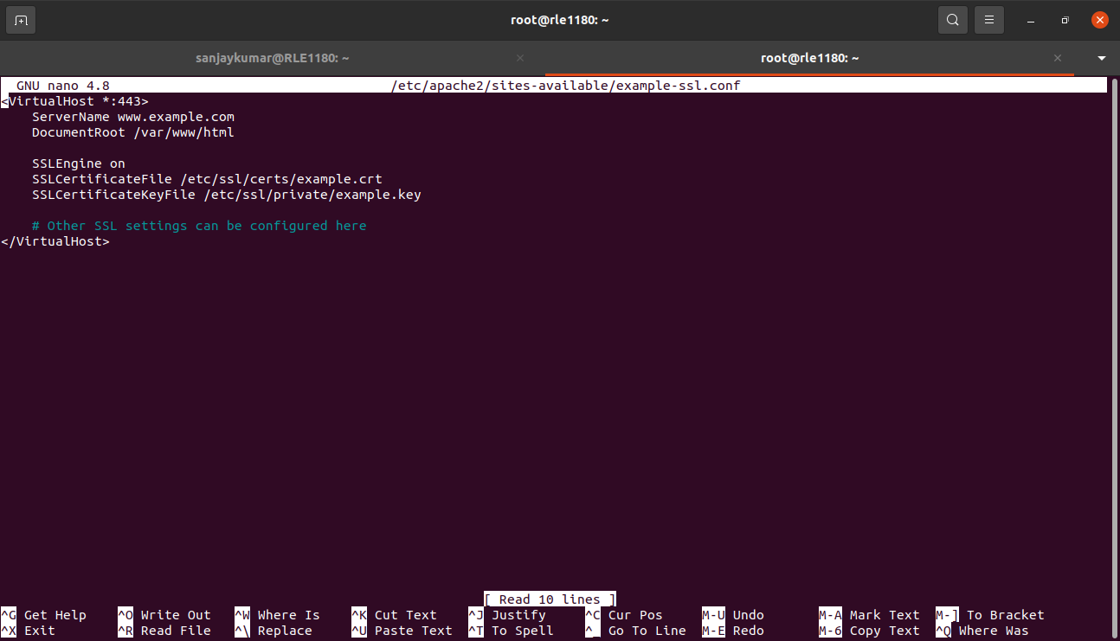
- Enable the SSL site and the SSL module:
sudo a2ensite example-ssl
sudo a2enmod ssl
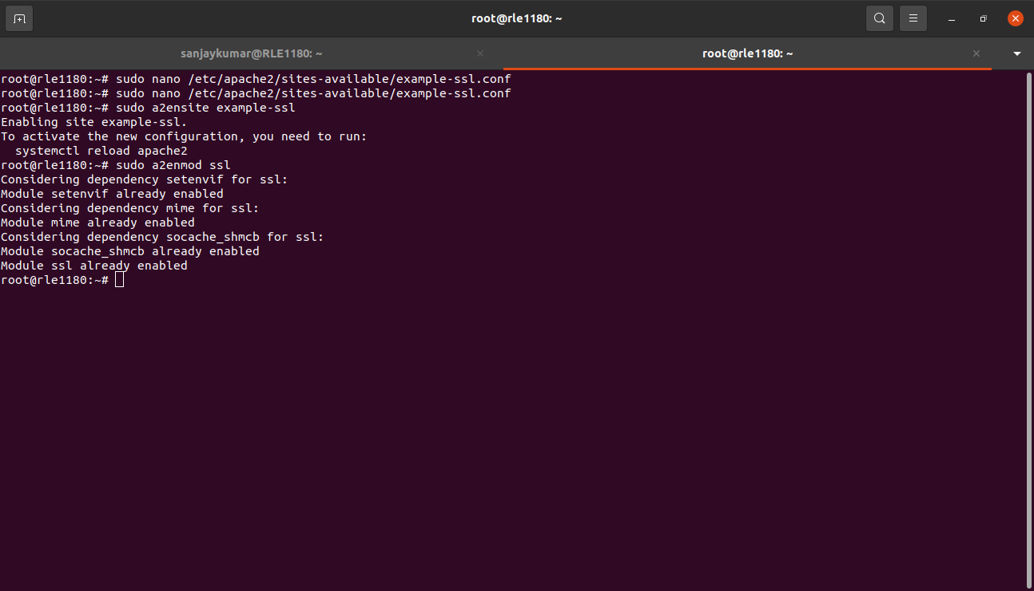
- Restart you apache2 to apply the changes:
sudo systemctl restart apache2

Step 2 : security implications of self-signed certificates :

- No Browser Trust : Web browsers do not trust self-signed certificates by default. This means visitors to your website will encounter security warnings, which can deter users and undermine trust.
- Vulnerability to man-in-the-middle Attacks : Self-signed certificates are vulnerable to man-in-the-middle (MITM) attacks because there's no trusted third-party authority verifying the certificate's authenticity.
- No certificate Revocation : Self-signed certificates do not have the benefit of certificate revocation, making it challenging to revoke a certificate in case it's compromised.
- Lack of Accountability : Self-signed certificates do not provide accountability. They don't confirm the identity of the website owner or organization.
- Limited Browser Compatibility : Some older browsers and devices may not support or recognize self-signed certificates.

